**Bandit level 2**

“The password for the next level is stored in a file called **-** located in the home directory”

I ran the command ls and found the – file

I tried to run cat, cd, file etc. and could not open the file

I then ran the file:



And got the password!

Copying it here for next level:

CV1DtqXWVFXTvM2F0k09SHz0YwRINYA9

I am now in bandit2

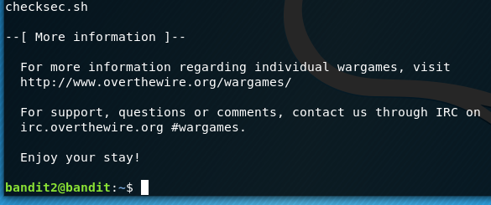

Success!